**UNIVERSITY OF BUEA**

**FACULTY OF ENGINEERING AND TECHNOLOGY**



**DEPARTMENT OF COMPUTER ENGINEERING (FET)**

**CEF 440: INTERNET PROGRAMMING (J2EE) AND MOBILE PROGRAMMING**

**UNIFIED MODELLING LANDUAGE DIAGRAMS DOCUMENT FOR A MARKET MANAGEMENT SYSTEM**

**28-04-2023**

**NAMES OF GROUP MEMBERS**

|  |  |
| --- | --- |
| 1. AMBE MBONG-NWI NCHANG | FE20A007 |
| 1. ASONGNA FRANK TONGWA | FE20A012 |
| 1. BESINGI NAURA MABOLA | FE20A023 |
| 1. FONGE BERTIN AMIN-SHU | FE20A040 |
| 1. NKWETAKEM TABO BRUNO | FE20A091 |

**Course Instructor**

DR. VALERY NKEMENI

**Table of Content**

1. Introduction ……………………………………………………………………………………………………………………………. 3
   1. Definition of Important Terms ………………………………………………………………………………………….. 3
   2. Why Use UML Diagrams? ………………………………………………………………………………………………….. 3
   3. Types of UML Diagrams …………………………………………………………………………………………………….. 3
   4. Diagrams Drawn for our Market Management System ……………………………………………………… 3
2. Diagrams Proper ……………………………………………………………………………………………………………………… 4

2.1 Context Diagram ……………………………………………………………………………………………………………….. 4

2.2 Use Case Diagram ………………………………………………………………………………………………………………. 5

2.3 Class Diagram …………………………………………………………………………………………………………………….. 6

2.4 Sequence Diagrams ……………………………………………………………………………………………………………. 6

2.5 State Diagram …………………………………………………………………………………………………………………… 18

2.6 Activity Diagram ……………………………………………………………………………………………………………….. 19

1. Use Case Scenarios …………………………………………………………………………………………………………………. 20
2. **Introduction**

This document explicitly shows us the various UML diagrams drawn for our Market Management System.

* 1. **Definition of Important Terms**
* **UML (Unified Modeling Language)**

UML is a standardized modeling language consisting of an integrated set of diagrams, developed to help system and software developers for specifying, visualizing, constructing, and documenting the artifacts of software systems, as well as for business modeling and other non-software systems.

* **UML Diagram**

A UML diagram is the blueprint of the software architecture. In other words, it is a general-purpose way to visualize the main concepts of object-oriented concepts used in software.

* 1. **Why Use UML Diagrams?**
* **Problem Solving:** These diagrams help us reduce cost and improve product quality especially for complex systems by breaking them down for a better understanding of user needs.
* **Improve Productivity:** Using these diagrams enables all team members to be on the same page hence saving time.
* **Easy to Understand:** These diagrams offer both professional and non-professional developers (stakeholders, business researchers) a clear presentation of the requirements, functions, and processes of the system
  1. **Types of UML Diagrams:**

There are two main categories which are:

* **Structural Diagrams:** Structural diagrams show the static structure of the system, such as the classes, objects, components, interfaces, and relationships among them.
* **Behavioral Diagrams:** They show the dynamic behavior of the system, such as the interactions, collaborations, state transitions, and activities of the system elements.
  1. **Diagrams Drawn for our Market Management System**

For our system, we have a **Context Diagram** and five (5) different UML diagrams which are:

* Use Case Diagram (Behavioral Diagram)
* Class Diagram (Structural Diagram)
* Sequence Diagram (Behavioral Diagram)
* State Diagram (Behavioral Diagram)
* Activity Diagram (Behavioral Diagram)

1. **Diagrams Proper**
   1. **Context Diagram**

This is NOT a UML diagram. It is a Level 0 data flow diagram that shows how a system interacts with external entities such as people, organizations, or other systems.

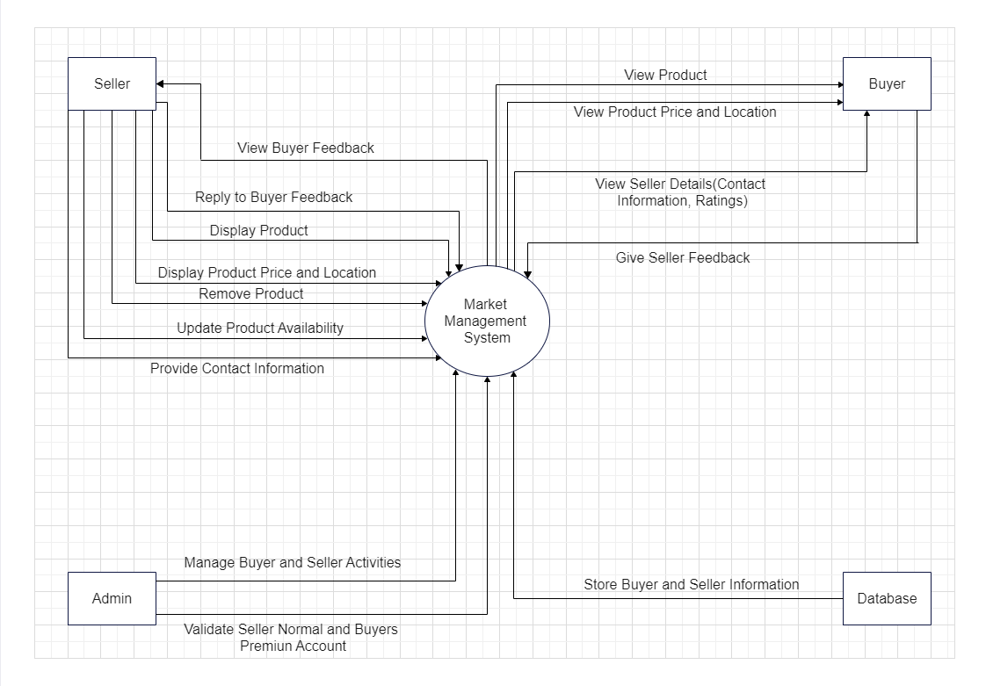

* 1. **Use Case Diagram**

This is the first diagram in the UML model. It helps us demonstrate users’ needs and consequently the expected behavior of the system. This diagram captures the functional requirements of the system from the perspective of the users and stakeholders. It shows the actors, use cases, and their relationships. It helps to define the scope and boundaries of the system and identify the main features and functionalities.

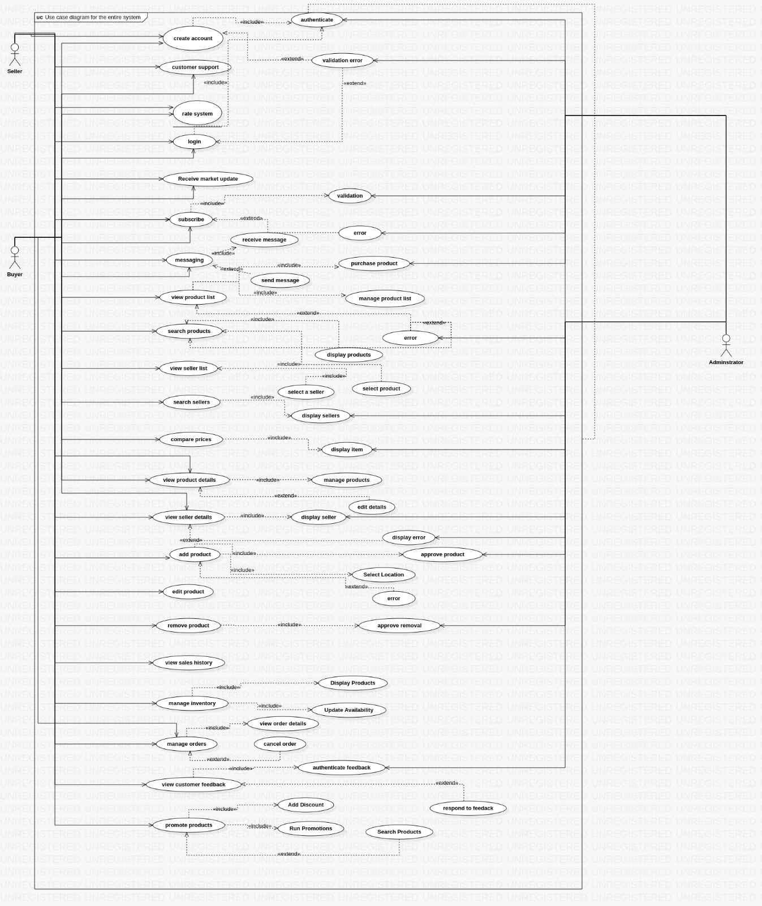

* 1. **Class Diagram**

This is the second diagram in the UML model. This diagram represents the static structure of the system in terms of classes, attributes, methods, and associations. It shows the logical organization of the system and how data and behavior are encapsulated and related. It helps to define the domain model and design the system architecture.

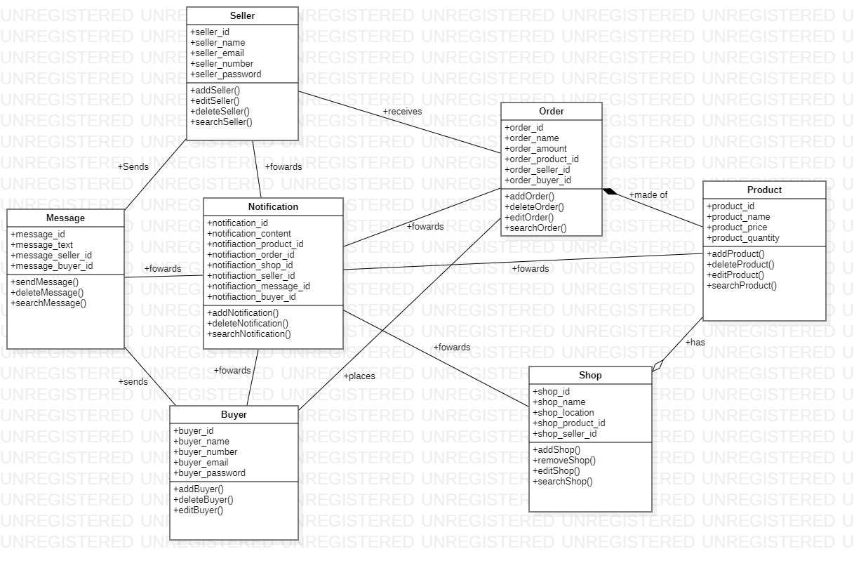

* 1. **Sequence Diagrams**

This is the third diagram in the UML model. This diagram illustrates the dynamic behavior of the system in terms of interactions between objects over time. It shows the objects, messages, lifelines, and activation bars. It helps to describe how use cases are realized and how objects collaborate to achieve a goal.

Here, a sequence diagram was drawn for each of the 22 use cases as seen below:

**Use Case 1: Create an Account**

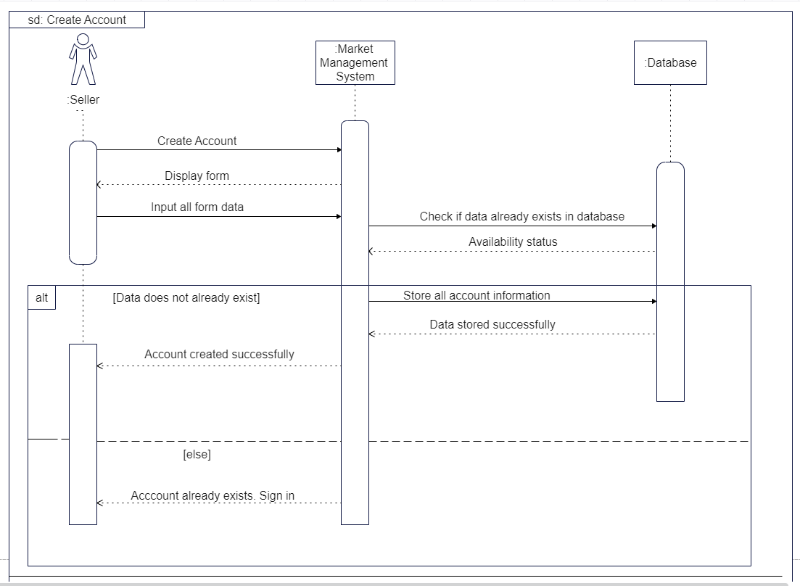

**Use Case 2: Login**

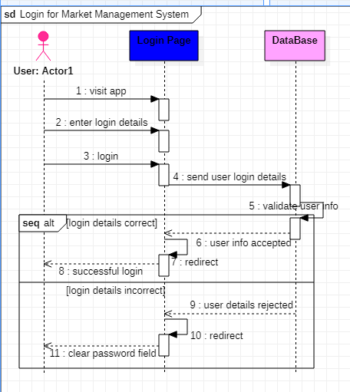

**Use Case 3: Forgot Password**

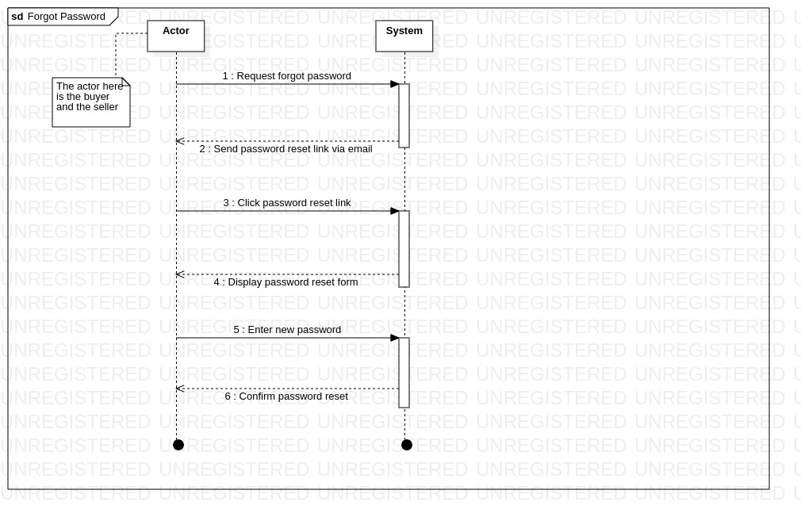

**Use Case 4: Rate Vendor**

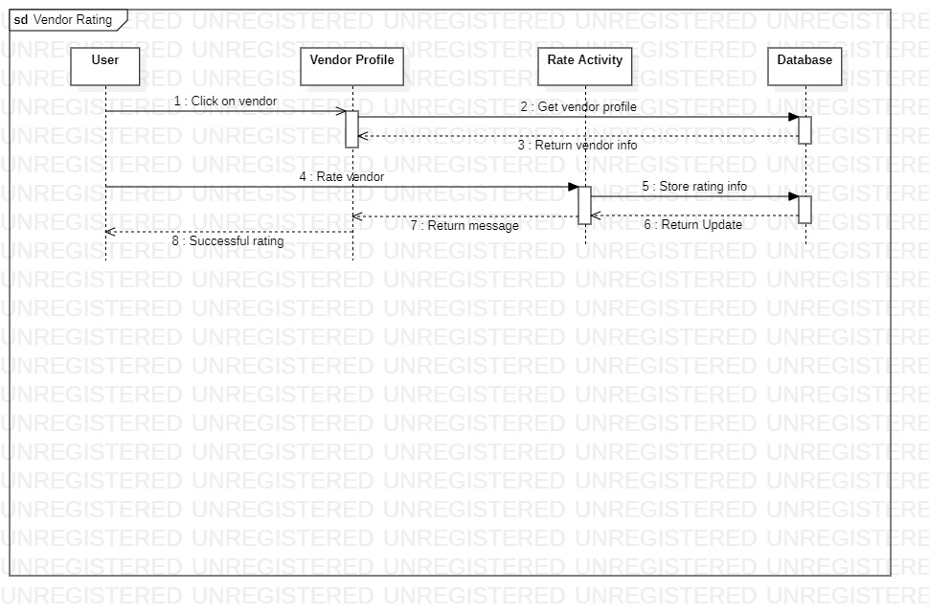

**Use Case 5: Subscribe**

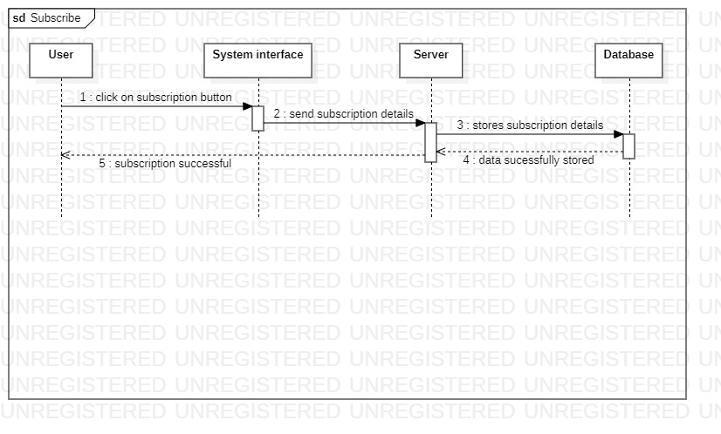

**Use Case 6: Messaging**

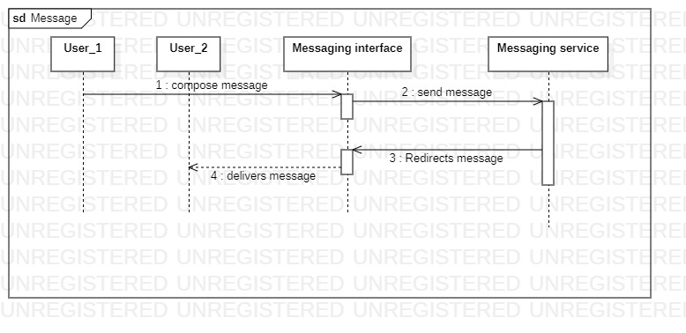

**Use Case 7: Customer Support**

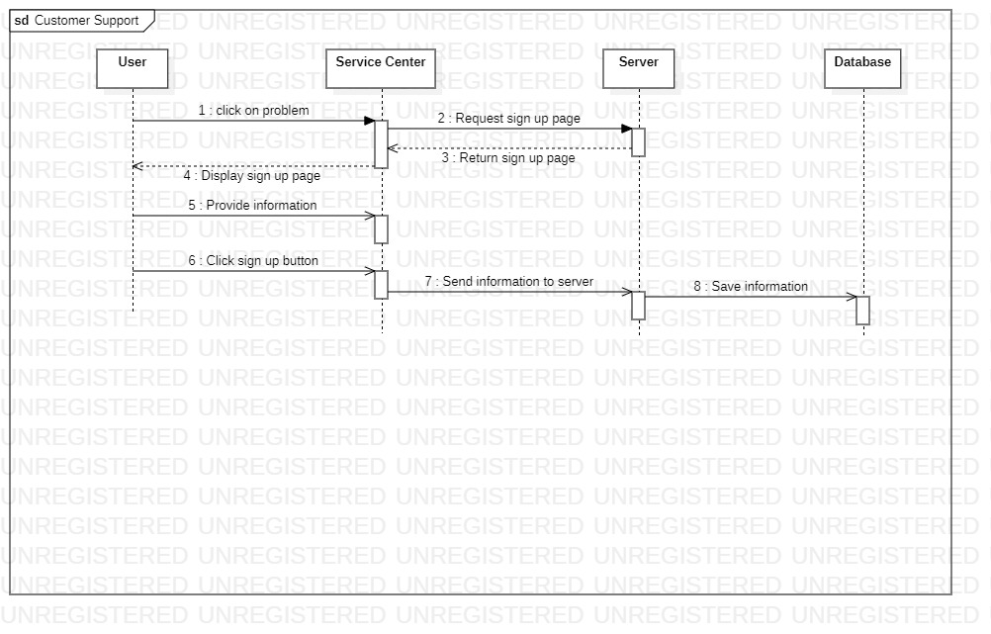

**Use Case 8: Receive Market Update**

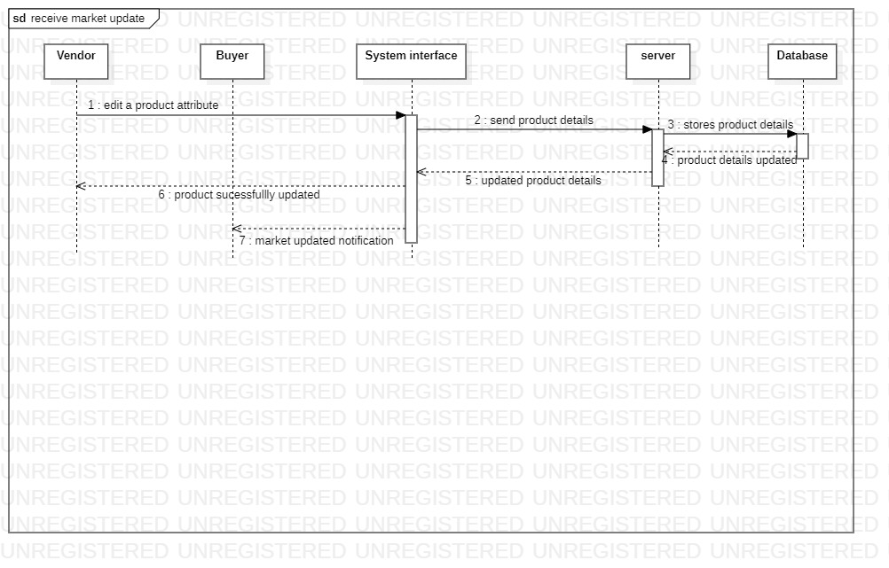

**Use Case 9: View Product List**

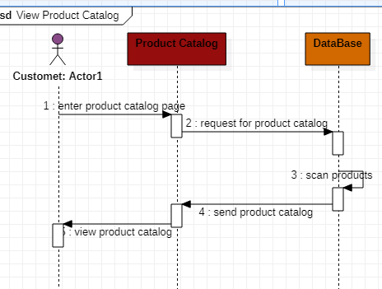

**Use Case 10: Search Products**

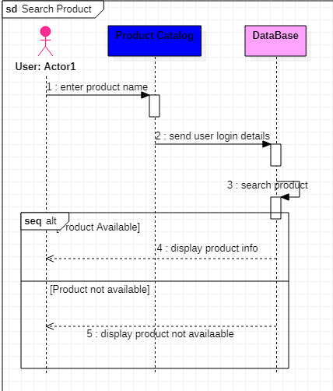

**Use Case 11: View Seller List**

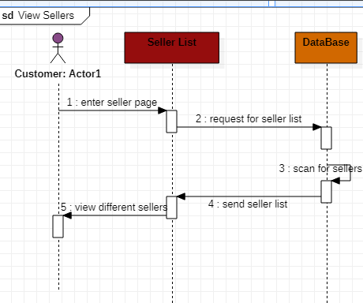

**Use Case 12: Search Sellers**

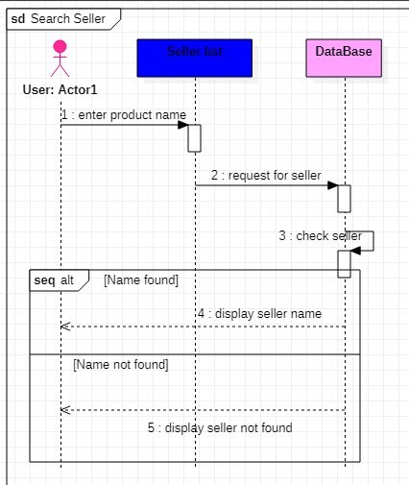

**Use Case 13: View Product Details**

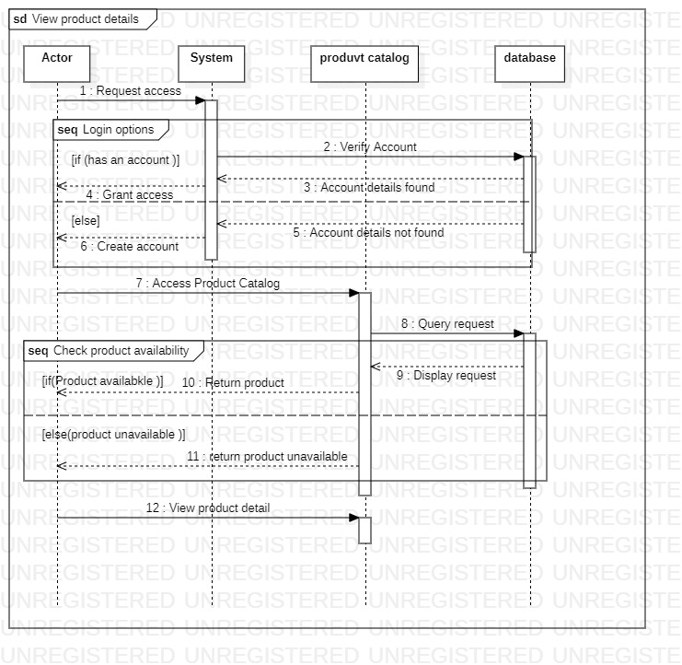

**Use Case 14: View Seller Details**

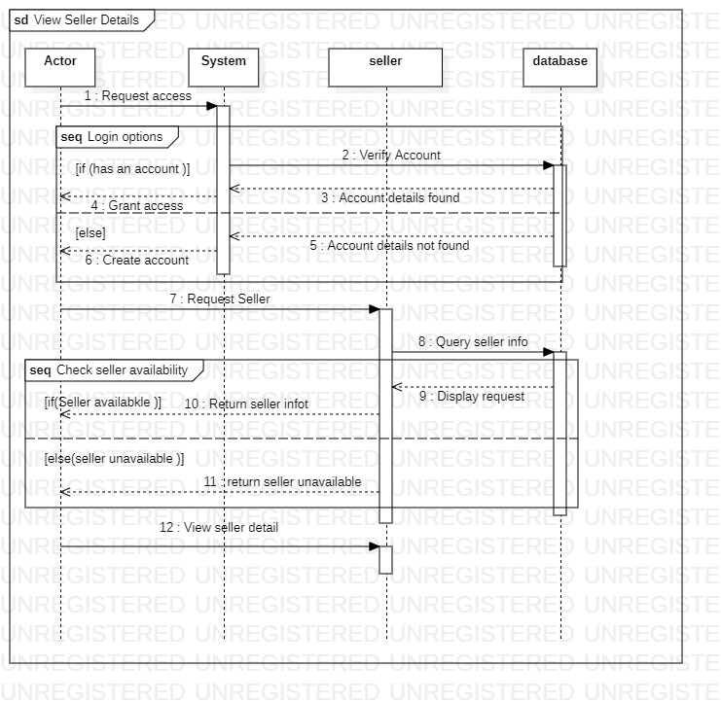

**Use Case 15: Add Product**

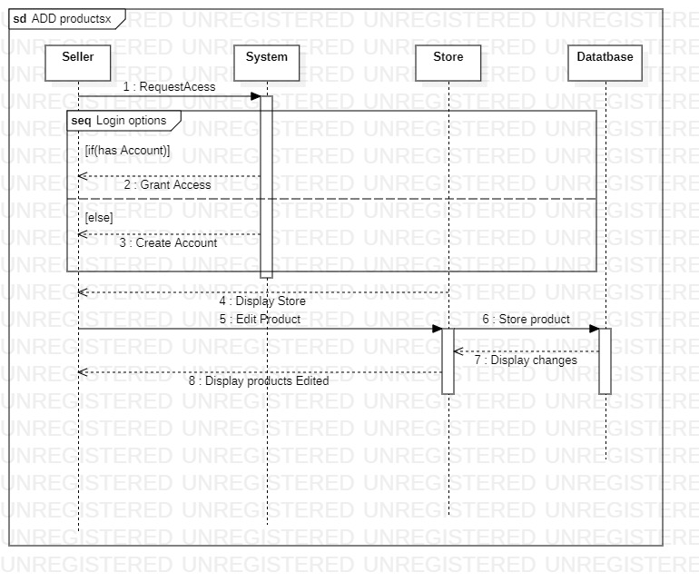

**Use Case 16: Edit Product**

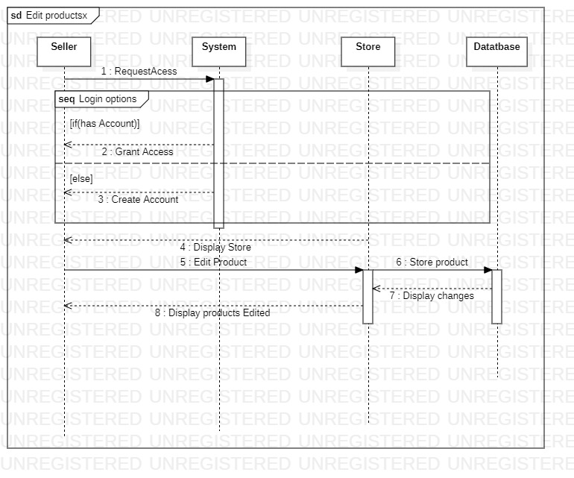

**Use Case 17: Remove Product**

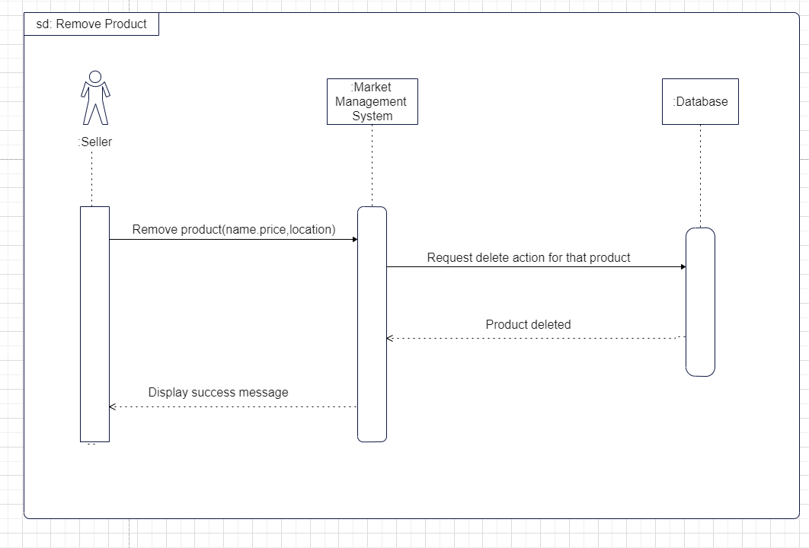

**Use Case 18: View Sales History**

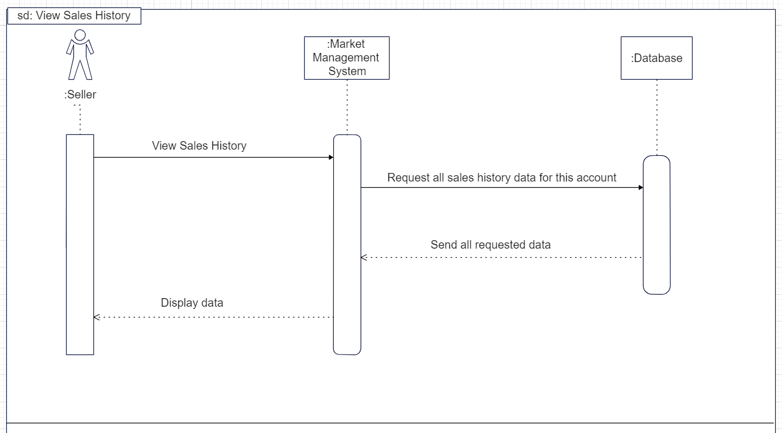

**Use Case 19: Manage Inventory**

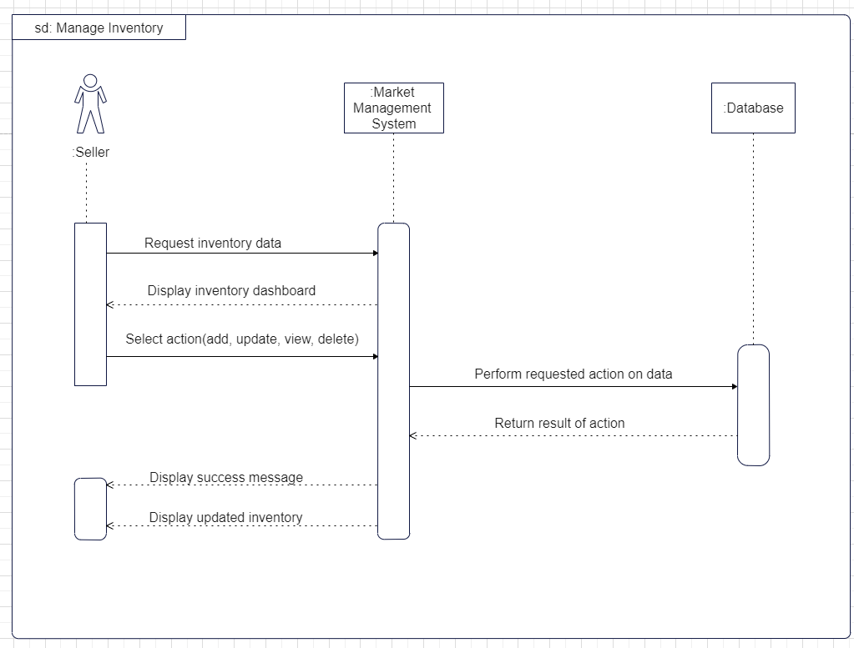

**Use Case 20: Promote Products**

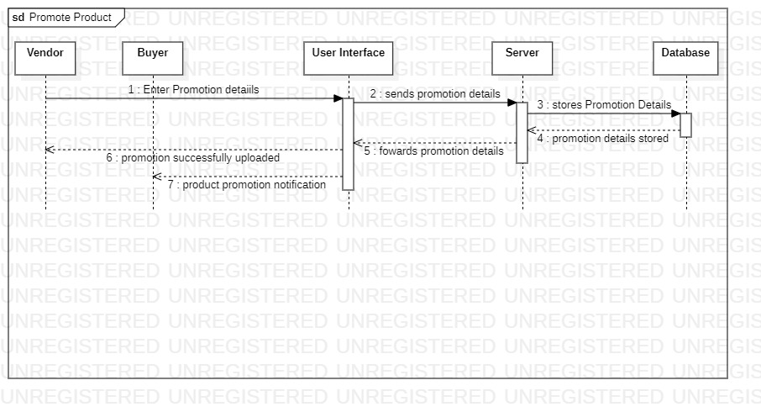

**Use Case 21: Manage Orders**

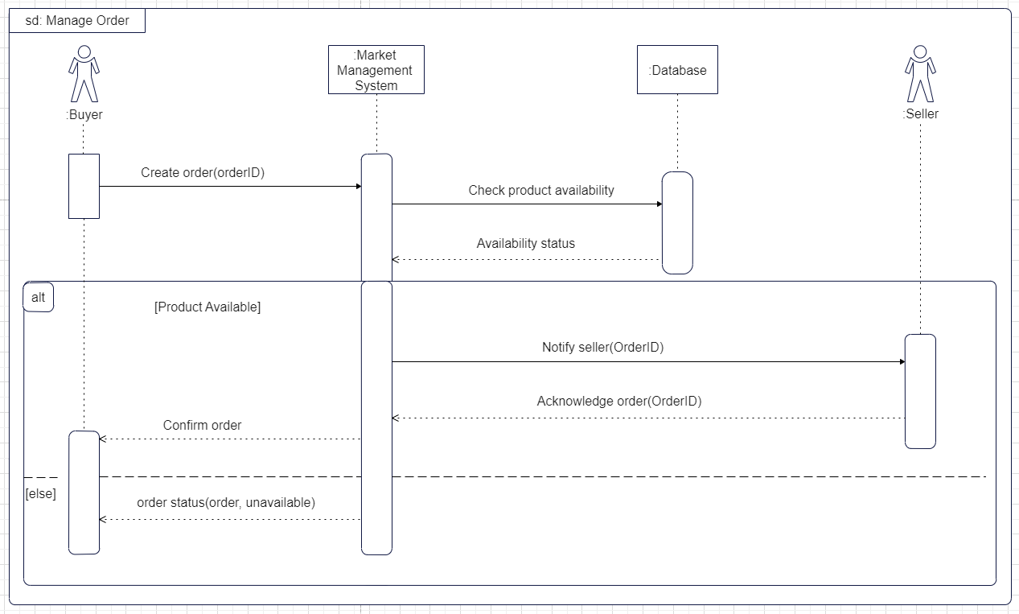

**Use Case 22: View Customer Feedback**

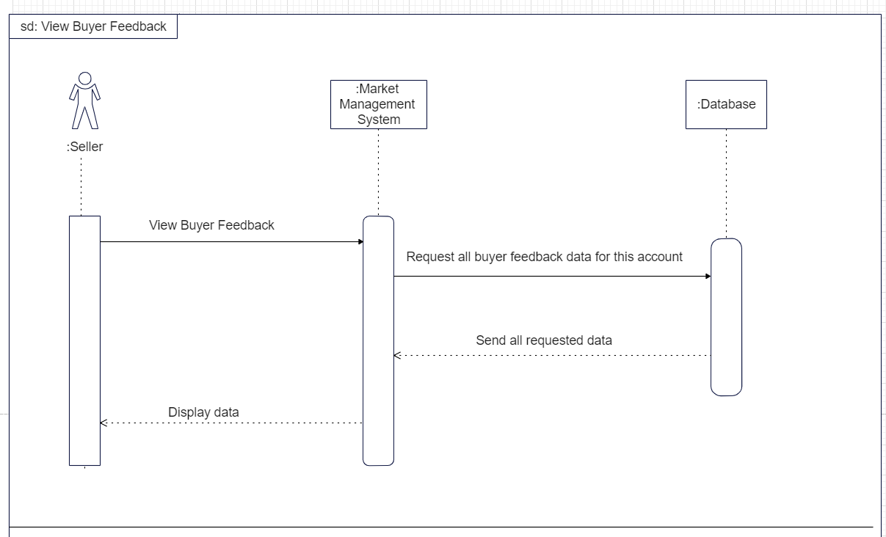

* 1. **State Diagram**

This is the fourth diagram in the UML model. This diagram depicts the dynamic behavior of an object or a part of the system in terms of states, transitions, events, and actions. It shows how an object changes its state in response to internal or external stimuli. It helps to specify the behavior and logic of an object or a subsystem.

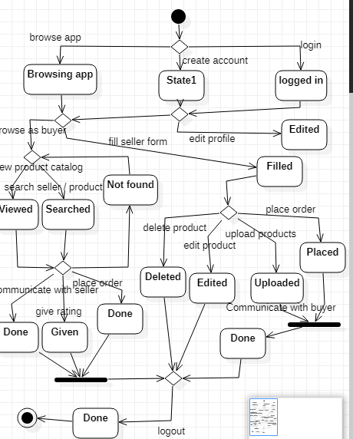

* 1. **Activity Diagram**

This diagram models the dynamic behavior of the system in terms of activities, actions, flows, and decisions. It shows how control and data flow through the system and how parallelism and synchronization are handled. It helps to represent workflows and business processes.

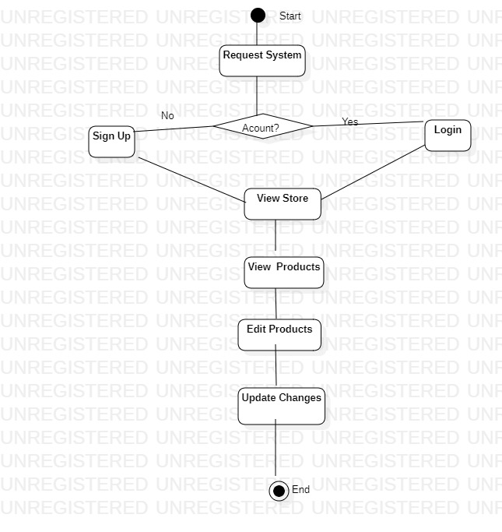

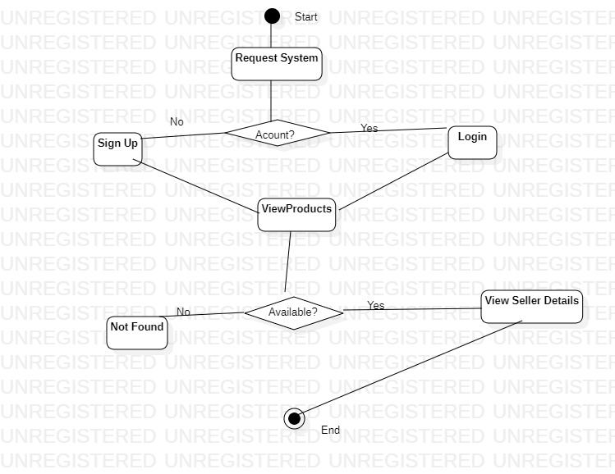

1. **Use Case Scenarios**

|  |  |
| --- | --- |
| **Use Case 1** | **Create Account** |
| Actors | Seller, Buyer, Administrator |
| Preconditions | None |
| Postconditions | The actor has successfully created a new account |
| Flow of Events | 1. The actor selects the "Create Account" option on the system interface. 2. The system presents the account creation form, which includes fields for username, password, email, and phone number. 3. The actor enters the required information into the form and submits it. 4. The system verifies the entered information and creates a new account for the actor. 5. The system displays a confirmation message to the actor. |
| Includes | authentication |
| Extensions | validation error |

|  |  |
| --- | --- |
| **Use Case 2** | **Login** |
| Actors | Seller, Buyer, Administrator |
| Preconditions | The user must have an account in the system |
| Postconditions | The user is authenticated and granted access to their respective dashboard |
| Flow of Events | 1. The user clicks on the login button on the website. 2. The system displays the login page, prompting the user to enter their username and password. 3. The user enters their username and password and clicks the "login" button. 4. The system authenticates the user's credentials by checking them against the stored user data. 5. If the authentication is successful, the system grants the user access to their respective dashboard. 6. If the authentication fails, the system displays an error message and prompts the user to try again. |
| Includes | Authenticate |
| Extensions | Validation error |

|  |  |
| --- | --- |
| **Use Case 3** | **Forgot Password** |
| Actors | Seller, Buyer, Administrator |
| Description | This use case helps users generate a new password after email authentication if the previous password has been forgotten |
| Preconditions | The user already has an account created |
| Postconditions | New password generated |
| Flow of Events | 1. User clicks forgot password button 2. Password reset link is sent to the email 3. User clicks the link in the email and the password reset form is displayed 4. User enters a new password 5. System stores a new password and sends a success message. |
| Includes | None |
| Extensions | None |

|  |  |
| --- | --- |
| **Use Case 4** | **Rate System** |
| Actors | Seller, Buyer, Administrator |
| Description | 1. The rate system allows buyers to rate and review products they have purchased from sellers on the online marketing portal. 2. The system captures and stores the rating and review data in the database for future reference. 3. The seller can view the ratings and reviews of their products, as well as respond to reviews. 4. The buyer can update or delete their reviews within a certain time frame. 5. The administrator can view and manage all reviews and ratings on the system, including deleting inappropriate reviews or suspending users who violate the platform's policies. |
| Includes | None |
| Extensions | None |

|  |  |
| --- | --- |
| **Use Case 5** | **Subscribe** |
| Actors | Seller, Buyer, Administrator |
| Description | This use case describes the process of subscribing to the online marketing portal to access the features and services provided by the system. |
| Preconditions | The user is not subscribed to the online marketing portal. |
| Postconditions | The user is subscribed to the online marketing portal and has access to the features and services provided by the system. |
| Flow of Events | 1. The user navigates to the online marketing portal. 2. The user clicks on the "Subscribe" button. 3. The system prompts the user to register or login to their existing account. 4. If the user doesn't have an account, they can register by providing their personal information and creating a new account. 5. If the user has an account, they can log in using their username and password. 6. Once logged in, the user can manage their products, sell products, buy products, and access admin management features. 7. The user can also search for products, compare prices, and add products to their cart. |
| Includes | Register |
| Extensions | None |
| Alternate Flow | If the user enters invalid login credentials, the system displays an error message and prompts the user to try again.  If the user encounters technical difficulties during the subscription process, the system displays an error message and prompts the user to contact customer support for assistance. |

|  |  |
| --- | --- |
| **Use Case 6** | **Messaging** |
| Actors | Seller, Buyer |
| Description | This use case represents the messaging functionality within the online marketing portal system. It allows communication between sellers, buyers, and administrators. |
| Preconditions | The seller and buyer must be logged in to the system. |
| Postconditions | The seller has messaged the buyer and vice versa |
| Includes | Send Message: The ability for sellers and buyers to send messages to each other. |
| Extensions | Receive Message: Sellers, buyers, and administrators can receive messages from other users. |

|  |  |
| --- | --- |
| **Use Case 7** | **Customer Support** |
| Actors | Buyer, Seller, Administrator |
| Description | This use case describes the process of providing customer support to users of the online marketing portal. |
| Preconditions | The user has contacted the customer support service of the online marketing portal. |
| Postconditions | The user's issue or inquiry has been resolved or escalated to the appropriate party. |
| Includes | None |
| Extensions | None |

|  |  |
| --- | --- |
| **Use Case 8** | **Receive Market Update** |
| Actors | Seller, Buyer, Administrator |
| Description | This use case describes the process of receiving market updates, which includes information about new products, prices, and locations. |
| Preconditions | 1. The Online Marketing Portal is running. 2. The Seller, Buyer, or Administrator is logged in. |
| Postconditions | 1. The Seller, Buyer, or Administrator is informed about the market updates. 2. The market updates are displayed on the Online Marketing Portal. |
| Flow of Events | 1. The system detects new market updates. 2. The system sends notifications to the Seller, Buyer, and Administrator. 3. The Seller, Buyer, or Administrator receives the notification. 4. The Seller, Buyer, or Administrator reviews the market update. |
| Includes | None |
| Extensions | None |

|  |  |
| --- | --- |
| **Use Case 9** | **View Product List** |
| Actors | Buyer, Seller, Administrator |
| Preconditions | 1. The Buyer is registered and logged into the system. 2. The Seller has added their products to the system. 3. The Administrator has approved the Seller's products. |
| Postconditions |  |
| Flow of Events | 1. The Buyer selects the "View List of Products" option from the system menu. 2. The system displays a list of available products and their prices, sorted by category or seller. 3. The Buyer can filter the list by category, location, or price range. 4. The Buyer selects a product from the list to view its details and location. 5. 5. The system displays the product details, including the name, description, price, location, and seller contact information. |
| Includes | display error |
| Extensions | 1. Purchase product 2. manage product list |

|  |  |
| --- | --- |
| **Use Case 10** | **Search Products** |
| Actors | Buyer |
| Description | Buyers can search for specific products in the market and view their prices and availability. |
| Preconditions | The buyer is logged in to the system. |
| Flow of Events | 1. The buyer enters the keywords for the product they are searching for in the search bar. 2. The system displays a list of matching products with their prices and availability. 3. The buyer selects a product from the list to view its details. 4. The system displays the details of the selected product, including its price, location, and seller information. 5. The buyer can add the product to their shopping cart or continue searching for other products. |
| Includes | 1. display products 2. select product |
| Extensions | None |

|  |  |
| --- | --- |
| **Use Case 11** | **View Seller List** |
| Actors | Buyer, Seller, Administrator |
| Description | This use case allows the buyer to view a list of sellers and their locations in the market. |
| Preconditions | The buyer has logged into the online marketing portal. |
| Postconditions | The list of sellers and their locations is displayed for the buyer. |
| Flow of Events | 1. The buyer selects the "View Seller List" option. 2. The system displays a list of sellers and their locations. 3. The buyer can filter the list based on location or product category. 4. The buyer selects a seller from the list. 5. The system displays the products offered by the selected seller and their prices. 6. The buyer can select a product to view more details or add it to their cart. |
| Includes | select a seller |
| Extensions | None |
| Exceptions | 1. If there are no sellers registered in the system, the system displays a message indicating that no sellers are available. 2. If the buyer enters an invalid location or product category, the system displays an error message and prompts the buyer to enter valid criteria. 3. If the selected seller has no products listed, the system displays a message indicating that no products are available for that seller. |

|  |  |
| --- | --- |
| **Use Case 12** | **Search Sellers** |
| Actors | Buyer, Seller, Administrator |
| Description | The buyer searches for sellers who have listed products for sale. |
| Preconditions | The buyer is logged in and has access to the search feature. |
| Postconditions | The buyer is presented with a list of sellers who match their search criteria, along with their products, prices, and locations. The buyer can select a seller to view more information about them and their products. |
| Includes | display seller |
| Extensions | None |

|  |  |
| --- | --- |
| **Use Case 13** | **View Product Details** |
| Actors | Seller, Buyer, Administrator |
| Description | 1. The Seller, Buyer, or Administrator can initiate the "View Product Details" use case. 2. The Seller wants to display the details of a product they are selling, including the price and location. 3. The Buyer wants to review the details of a product, such as its description, price, and availability. 4. The Administrator wants to monitor the product listings and ensure they comply with platform policies. |
| Includes | manage products |
| Extensions | Edit details |

|  |  |
| --- | --- |
| **Use Case 14** | **View Seller details** |
| Actors | Customer, Seller, Administrator |
| Preconditions | The customer is logged in to the system. |
| Flow of Events | 1. The customer selects a seller they want to view the details of. 2. The system displays the seller's profile page, which includes their contact information, ratings, and reviews. 3. The customer can review the seller's details and decide whether or not to initiate a trade with the seller. |
| Includes | display seller |
| Extensions | Display error |

|  |  |
| --- | --- |
| **Use Case 15** | **Add Product** |
| Actors | Seller |
| Preconditions | The seller must be registered and logged into the system. |
| Postconditions | The product is added to the seller's list of products and displayed on the online marketing portal. |
| Flow of Events | 1. The seller selects the "Add Product" option from the system interface. 2. The system prompts the seller to provide details of the product, including the name, description, price, and location. 3. The seller enters the required details and submits the product for approval by the system administrator. 4. The system displays a confirmation message to the seller indicating that the product has been added and is pending approval. |
| Includes | 1. approve product 2. select location |
| Extensions | error |

|  |  |
| --- | --- |
| **Use Case 16** | **Edit Product** |
| Actors | Seller |
| Preconditions | The seller is logged in and has the necessary privileges to edit their product details. |
| Postconditions | The product details are updated in the database and the seller can view the updated details on their product page. |
| Flow of Events | 1. The seller selects the "Edit Product" option from the seller dashboard. 2. The system displays a form for editing the product details, including fields for the product name, description, price, and location. 3. The seller makes the desired changes to the product details and submits the form. 4. The system updates the product details in the database and displays a confirmation message to the seller. |
| Includes | None |
| Extensions | None |

|  |  |
| --- | --- |
| **Use Case 17** | **Remove Product** |
| Actors | Seller, Administrator |
| Description | This use case describes the process of removing a product from the online marketing portal system. A seller can initiate this use case by selecting a product they want to remove from their list of products. An administrator can also initiate this use case by selecting a product that violates the system's policies. |
| Preconditions | 1. The seller is logged into the system and has at least one product listed. 2. The administrator is logged into the system and has the necessary permissions. |
| Postconditions | The product is removed from the system and is no longer visible to buyers. |
| Flow of Events | 1. The seller selects the product they want to remove. 2. The system displays the details of the selected product, including its name, description, price, and images. 3. The seller clicks on the "Remove" button. 4. The system prompts the seller to confirm the removal. 5. The seller confirms the removal. 6. The system removes the product from the seller's list of products and updates the database accordingly. 7. The system notifies the seller that the product has been removed. |
| Includes | approve removal |
| Extensions | None |

|  |  |
| --- | --- |
| **Use Case 18** | **View Sales History** |
| Actors | Seller, Administrator |
| Description | Sellers can view their sales history, including the number of products sold, revenue generated, and customer feedback. |
| Preconditions | 1. The Seller has a registered account on the system. 2. The Seller has previously sold products through the system. |
| Postconditions | The Seller has viewed their sales history and can use it to improve their selling strategy. |
| Flow of Events | 1. The Seller logs in to the system. 2. The Seller navigates to the "View Sales History" feature. 3. The system presents the Seller with a list of their sales history, including the number of products sold, revenue generated, and customer feedback. 4. The Seller can review and analyze their sales history to improve their selling strategy.   5. The Seller logs out of the system. |
| Includes | None |
| Extensions | None |

|  |  |
| --- | --- |
| **Use Case 19** | **Manage Inventory** |
| Actors | Seller |
| Description | The seller can manage their inventory by adding, updating, or deleting product listings. |
| Preconditions | 1. The seller is logged in to the system. 2. The seller has the necessary permissions to manage their inventory. |
| Flow of Events | 1. The seller selects the "Manage Inventory" option from the main menu. 2. The system displays a list of the seller's current product listings. 3. The seller can add a new product listing by selecting the "Add Product" button and entering the product details (e.g., name, description, price, location, etc.). 4. The seller can update an existing product listing by selecting the listing from the list and modifying the details. 5. The seller can delete a product listing by selecting the listing from the list and confirming the deletion. 6. The system updates the inventory database with the changes made by the seller. |
| Includes | 1. display products 2. update availability |
| Extensions | None |

|  |  |
| --- | --- |
| **Use Case 20** | **Promote Products** |
| Actors | Seller, Buyer, Administrator |
| Description | This use case represents the process of sellers promoting their products on the online marketing portal, allowing buyers to discover and view the products. |
| Preconditions | Seller, Buyer, and Administrator are registered and logged into the system.  The seller has products available for promotion. |
| Postconditions | 1. The product listing is available for buyers to view and interact with. 2. Sellers can manage and update their product listings. 3. Administrators can review and approve/reject product listings as necessary. |
| Flow of Events | 1. The seller selects the "Promote Products" option in their account dashboard. 2. The system presents the seller with a form to enter details about the product, including the product name, description, price, and other relevant information. 3. The seller fills in the required information and submits the form. 4. The system validates the entered data and creates a product listing for the seller. 5. The system displays the product listing, including the product details, price, and any additional information provided by the seller. 6. The product listing becomes visible to potential buyers who can browse and search for products. 7. Buyers can view the product listing, including the product details, price, and seller information. 8. If interested, buyers can take further actions such as contacting the seller or adding the product to their shopping cart. |
| Includes | 1. add discount 2. run promotions |
| Extensions | Search products |

|  |  |
| --- | --- |
| **Use Case 21** | Manage Orders |
| Actors | Seller, Buyer, Administrator |
| Description | This use case describes the process of managing orders for both sellers and buyers through the online marketing portal system. |
| Preconditions | 1. Seller and buyer are registered and have logged in to the system. 2. Seller has posted products for sale and the buyer has selected products to purchase. |
| Postconditions | Seller and buyer have successfully managed their respective orders. |
| Flow of Events | 1. Seller and buyer log in to the system. 2. Seller posts products for sale with details including price and location. 3. Buyer searches for products and selects items to purchase. 4. System generates an order for the selected items with details including product name, quantity, price, and seller location. 5. Buyer confirms the order and makes payment. 6. Seller receives the order and confirms receipt of payment. 7. System updates the order status to "in progress". 8. Seller updates the order status to "shipped" and provides tracking information. 9. System updates the order status to "shipped" and sends notification to buyer. 10. Buyer receives the order and updates the order status to "received". 11. System updates the order status to "completed". 12. Seller and buyer can view the order details, including status and transaction history. 13. If necessary, the buyer can cancel or return the order through the "Cancel Order" or "Return Order" extensions, respectively. 14. System updates the order status accordingly and sends notifications to both seller and buyer. |
| Includes | View Order Details |
| Extensions | Cancel Order |

|  |  |
| --- | --- |
| **Use Case 22** | **View Customer Feedback** |
| Actors | Seller, Buyer, Administrator |
| Description | This use case allows Sellers, Buyers, and Administrators to view feedback and reviews from customers who have used the online marketing portal system. |
| Preconditions | The actor is logged into the system. |
| Postconditions | The actor has viewed the customer feedback and reviews. |
| Flow of Events | 1. The actor selects the "View Customer Feedback" option from the system's menu. 2. The system displays a list of customer feedback and reviews for products or transactions. 3. The actor can sort or filter the feedback by various criteria, such as date, product, or rating. 4. The actor can read the details of a particular feedback or review. 5. Includes: respond to customer feedback |
| Includes | None |
| Extensions | None |